The Case of
Lynda Mann

The first crime to be solved using DNA profiling.

Alison Graham
Paul Redmond
Teachers notes
The case of Lynda Mann
____________________________
Syllabus links:
Leaving Certificate Biology: 2.5.4 DNA structure
DNA profiling, stages involved, applications

Equipment required:
Per group of 2 students scissors
glue

What you need to do in advance:
Photocopy sheets

Expected results:

The DNA profile which matches the DNA at the crime scene is that of Colin Pichfork

The DNA analysis also proved that John Smith was innocent. DNA analysis is often used to prove people are innocent
Suggested answers to questions:
- Colin Pitchfork.
- The intron sections of DNA used in DNA profiling are very variable as they do not code for proteins and so mutations do not adversely affect the individual and are perpetuated. Identical twins arose by mitosis of one fertilised egg and so have identical DNA. Close relatives have similar DNA but there are clear differences between parents and children and between siblings. In court the chances of 2 individuals having the same DNA profile is quoted as 1 in 7 billion( the approx population of the world) but it is in fact less than that.
- Using a different restriction enzyme will mean the fragments are different sizes and the profiles will look different. However as long as the same restriction enzyme is used for the DNA from all the suspects and the crime scene the same match will be made.
- Colin Pitchfork avoided giving his own blood sample by sending a friend in to pose as him and give a blood sample in his place. This is now impossible as other forms of ID are used to verify identity such as photos, fingerprints etc

What actually happened in this case:

On 1st August 1987, four bakery workers were discussing the notorious sexual liaisons of a fellow employee when one of them four dropped a conversation thunderbolt – Colin, he said, had bullied him into giving the blood test on his behalf.

A woman sitting at the next table knew Colin Pitchfork, eventually contacted the Police. Colin Pitchfork was arrested and his DNA tested. It matched the profile of the murderer. Pitchfork was the the 4,583rd Male to be tested in this case.

John Smith was the first suspect to be eliminated by DNA Profiling.
- There are good arguments on both sides-the point is that this is a decision to be made by the people of a country but they need to be have some scientific knowledge to be able to make an informed decision.
FOR RETAINING PROFILES: Innocent have nothing to fear, deterrent to rapists, murderers who are more likely to be caught, costs reduced
AGAINST RETAINING PROFILES: Civil liberties, personal rights to DNA profile, may not be secure, other interested parties could gain access to it, mistakes or inaccuracies

The idea was adapted from ‘Who ate the cheese?’ www.biologycorner.com
Student worksheet
The Case of Lynda Mann

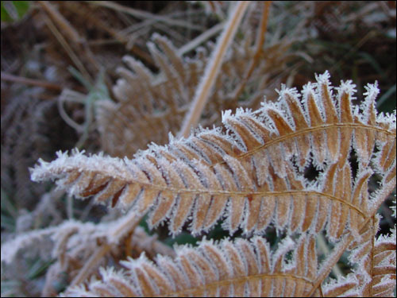
The crime
At 7.20am on November the 22, a hospital porter took his usual short cut to work along a lonely footpath. Sprawled on some grass and white with frost was the body of Lynda Mann. She had been strangled and raped the previous evening. Initial enquires failed to yield suspects but the police were convinced the killer was a local man and extended their search to all local villages, including Enderby, but with little success.

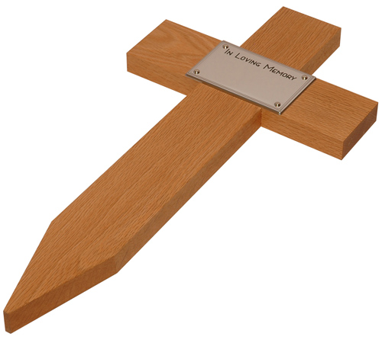
The investigation ground to a halt .On the first anniversary of Lynda’s death, someone left a cross on the spot where her body was found, and again on the second anniversary. Before it could happen a third time the killer struck again. Dawn Ashworth was also fifteen and a school girl from Enderby who was found less than a mile from where Lynda died. Semen DNA profiles confirmed that the killer was the same man.

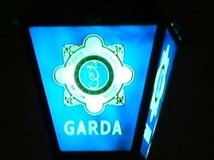
The decision was made to DNA profile all men living in the area to try to find the killer but no match was found.

You are a DNA specialist in the Forensic Laboratory. You are asked to test the DNA of 4 suspects who have since come to the attention of the police. Which, if any, have DNA which matches that of the killer?

John Smith (Suspect 1) was a porter at the local hospital who seemed to know a lot about the killing of Dawn. He confessed to Dawn’s murder when questioned, but police are suspicious.

Dean Blake (Suspect 2): A previous boyfriend of Dawn who also knew Lynda.

Colin Pitchfork (Suspect 3): An outpatient at the local hospital who came under suspicion following a conversation overheard in a pub

James Denver (Suspect 4): A local man who had previously been accused of rape although there was not enough evidence to convict him.

What you need to know!
You are going to carry out the DNA profiling!
DNA profiling is
- a process / technique of analysis
- revealing unique patterns of an individual’s DNA
- involving the non-coding regions of DNA (introns, VNTR) where we are most variable

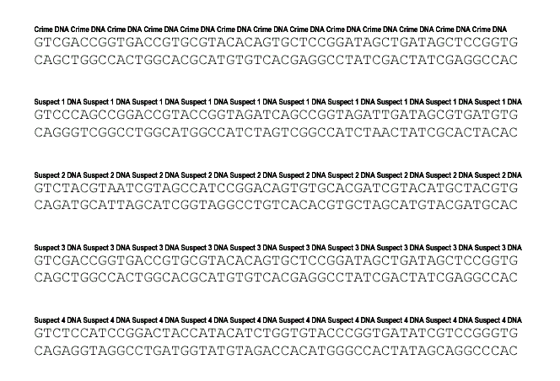
The DNA Samples

What you need to do to solve the crime
Work through each stage of DNA profiling with each sample- be careful to label them carefully and not to get them muddled up!

Stage in DNA profiling | What to do
1. Extraction  The DNA is extracted from the cells using chemicals and enzymes. In a blood sample this will be from the white blood cells as the red blood cells do not have nuclei and so will not contain DNA | Cut the DNA section for a suspect carefully from the page
2. Cutting with restriction enzymes  DNA is treated with restriction enzymes. Each enzyme cuts the DNA at a particular base sequence. | Use your scissors as the restriction enzyme and cut the DNA between the  C and G every time you find a CCGG sequence.
3. Fragment separation by gel electrophoresis  Mixture of DNA fragments is placed on the gel  The fragments have a negative charge and are attracted to the + terminal  The shorter fragments move faster | Count the number of base pairs (bp) in each fragment and write the number neatly on the back of all the fragments.  Stick each fragment onto the chart in the appropriate place- the shorter fragments are at the top because they travel fastest.
4. Analysis of fragment distribution  The fragments of DNA are made visible and compared. | Repeat this process for each suspect and compare the DNA profiles.

DNA Profiles from crime scene and suspects
1
2
3
4
5
6
7
8
9
10
11
12
13
14
15
16
17
18
19
20
21
22
23
24
25
26
27
28
29
30
+
+
+
+ ++

No of base pairs

Crime scene
John Smith
Dean
Blake
Colin Pitchfork
James
Denver
_
_
_
_
What have you found out?

1. Which suspect(s) if any are linked to the scene of the crime?
………………………………………………………………………………………………………………………………………………………………………………………………
2. How sure are you? What are the chances of 2 individuals having similar DNA profiles?
………………………………………………………………………………………………………………………………………………………………………………………………………………………………………………………………………………………………
3. What would have been the effect of using a different restriction enzyme which cuts the DNA at the sequence CGAT?
………………………………………………………………………………………………………………………………………………………………………………………………
4. All the suspects lived in the villages originally covered by the police when they took DNA profiles from all men. Can you guess how the killer was missed? Can you suggest what steps the gardai now take to avoid this?
………………………………………………………………………………………………………………………………………………………………………………………………………………………………………………………………………………………………
5. What do you think should happen to the DNA profiles of the innocent suspects in this case? Given the cost involved should the profiles be discarded or added to a database? Defend your viewpoint.
………………………………………………………………………………………………………………………………………………………………………………………………………………………………………………………………………………………………………………………………………………………………………………………………

